For SerialATA(SATA), a disk connected through supported SAS controller or supported on board SATA controllers. SATA disks are considered remote not local. These disks are not used as a scratch partition by default because they are seen as remote.

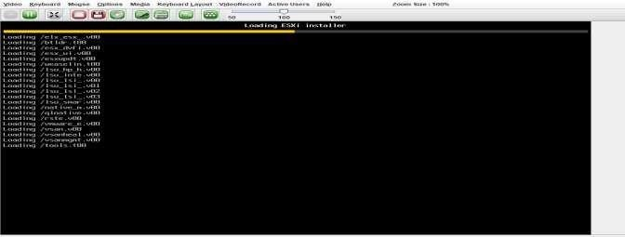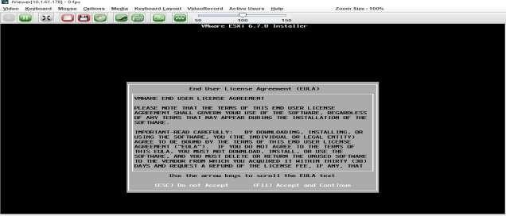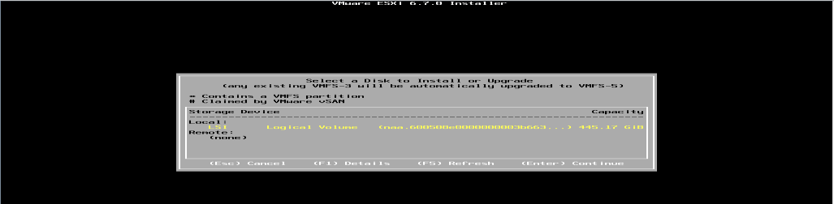

**ESXiInstaller: Accept Agreement:**

## Select storage :



**Select Keyboard Layout :**

## Set NodeESXi Root Password :

## Installation complete (Reboot)CLII interface to configuration

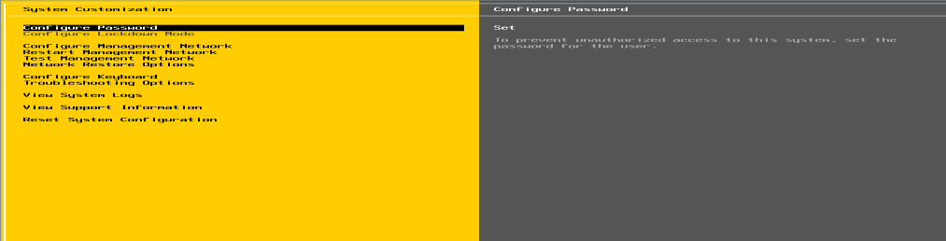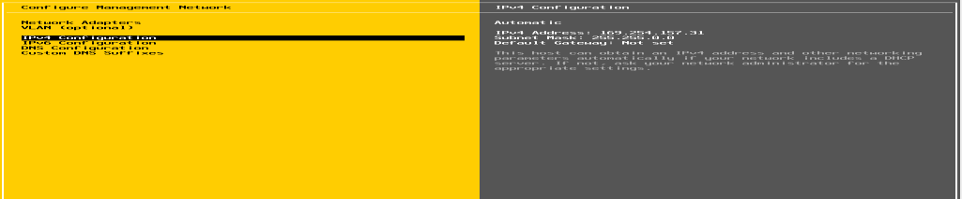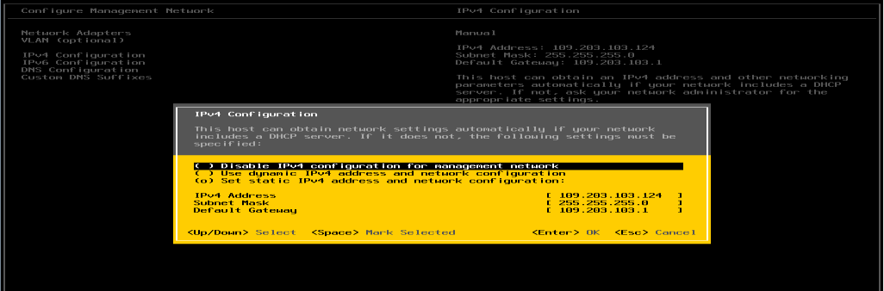

**CLI Interface to Configuration:**

## Configure Management Network

## Set IPV4

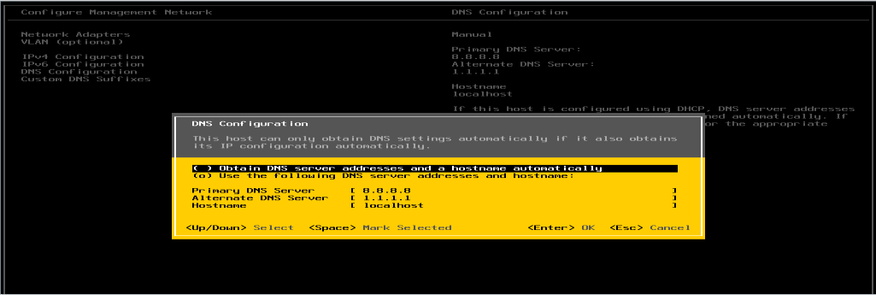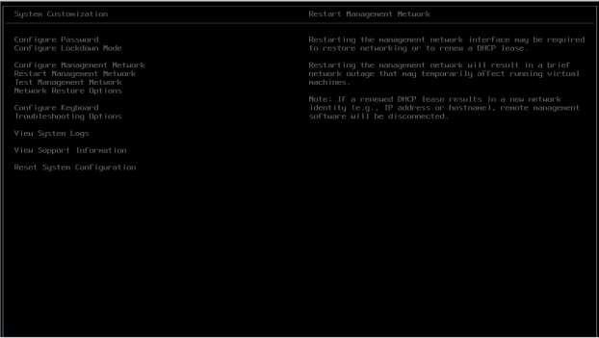

**Set DNSeriver :**

## Restart Management Network

## GUI Access:

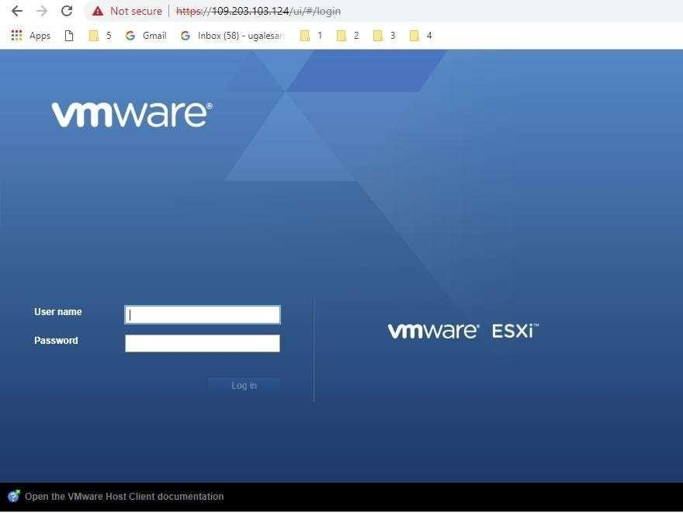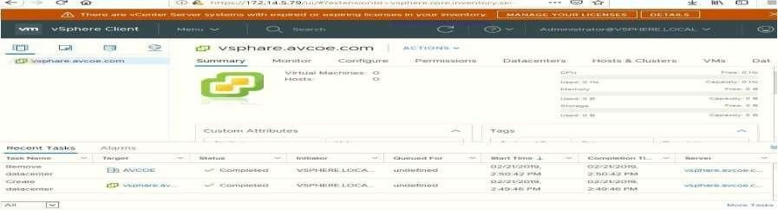

**ClusterSetup**

## Creating Datacenter

* **Creating Cluster**

## Adding Hosts in cluster

* **Resources after adding cluster.**

## DRS

* **Failover**

**VCenter Access:**

## Create Datacenter:

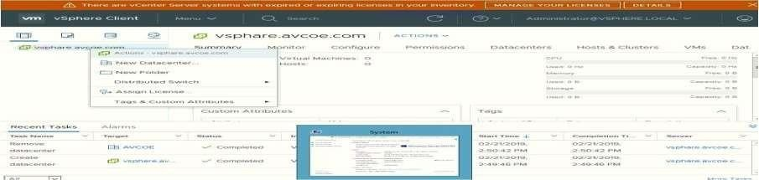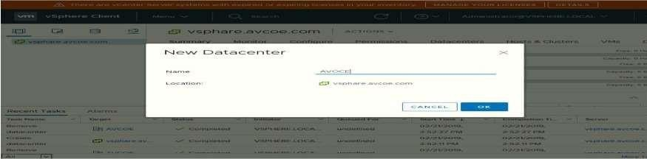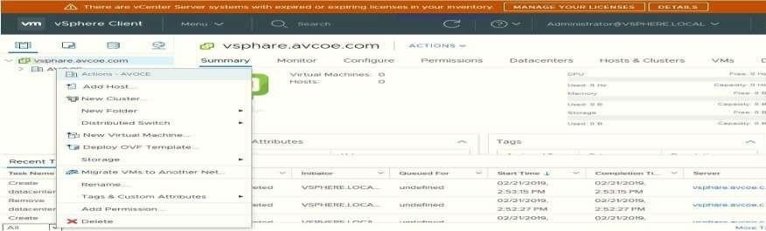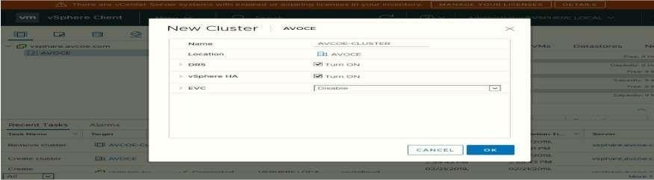

**Create cluster: Assign cluster name:**

## Add host.:

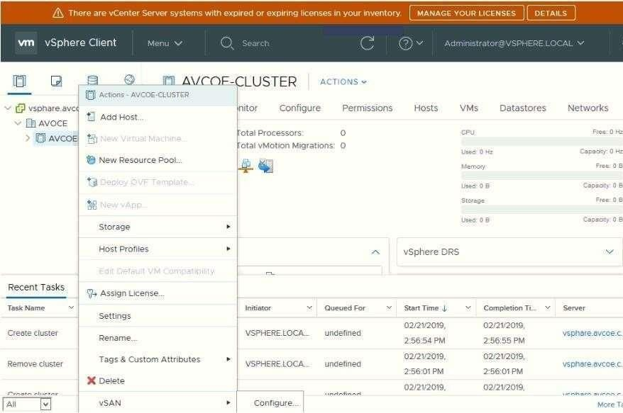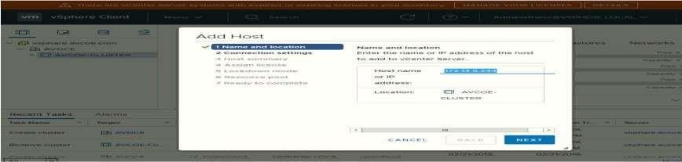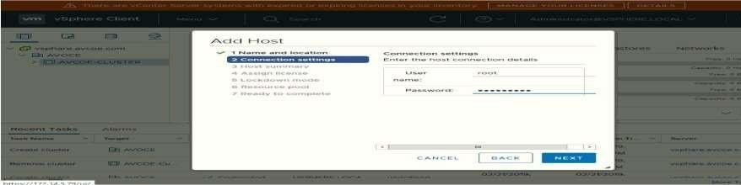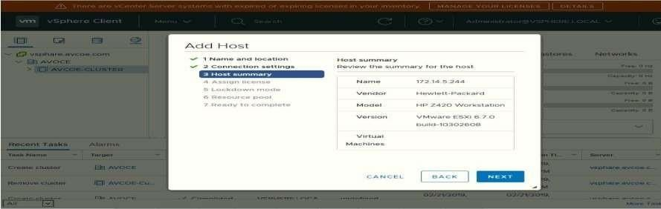

**Add host IP:**

## Enter host credential:

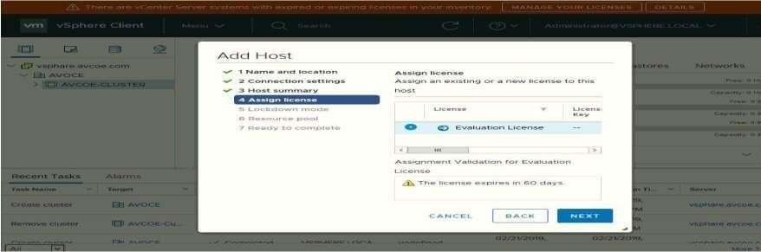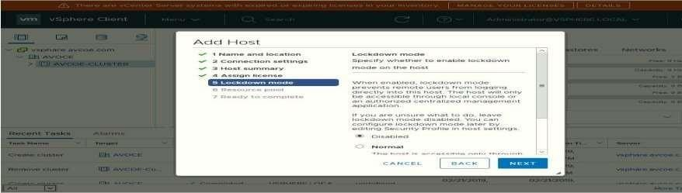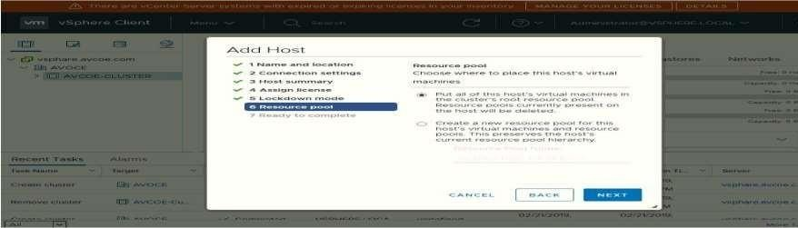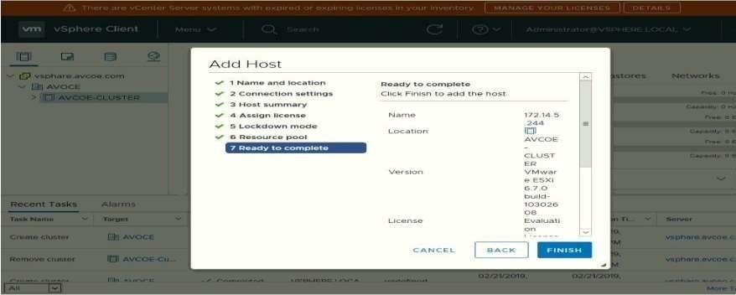

## Hot summary: Lock Down mode:

**Add Host In Pool:**

## Finish:

## Host View and View Config:

**Cluster View and Configuration:**

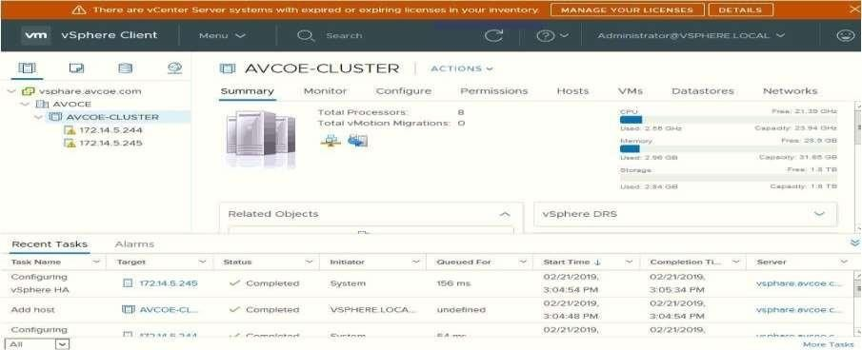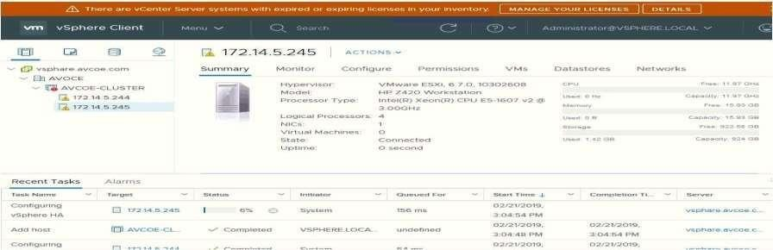

**Conclusion:** Like this we have configure VSphere Private Cloud